WEEK 2

SLF4J Hands-On Exercises

Exercise 1: Logging Error Messages and Warning Levels

import org.slf4j.Logger;

import org.slf4j.LoggerFactory;

public class LoggingExample {

    private static final Logger logger = LoggerFactory.getLogger(LoggingExample.class);

    public static void main(String[] args) {

        logger.error("This is an error message");

        logger.warn("This is a warning message");

    }

}

OUTPUT

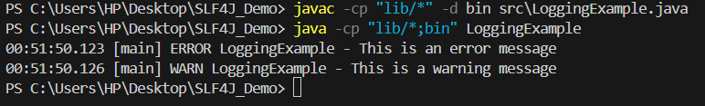

Exercise 2: Parameterized Logging

import org.slf4j.Logger;

import org.slf4j.LoggerFactory;

public class LoggingExample {

    private static final Logger logger = LoggerFactory.getLogger(LoggingExample.class);

    public static void main(String[] args) {

        String username = "Madhurima";

        int loginAttempts = 3;

        logger.info("User {} attempted to login {} times", username, loginAttempts);

    }

}

OUTPUT

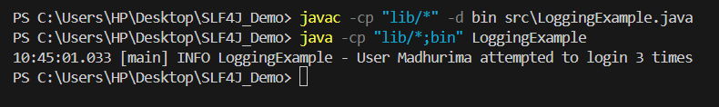

Exercise 3: Using Different Appenders

<configuration>

    <appender name="console" class="ch.qos.logback.core.ConsoleAppender">

        <encoder>

            <pattern>%d{HH:mm:ss.SSS} [%thread] %-5level %logger{36} - %msg%n</pattern>

        </encoder>

    </appender>

    <appender name="file" class="ch.qos.logback.core.FileAppender">

        <file>app.log</file>

        <encoder>

            <pattern>%d{HH:mm:ss.SSS} [%thread] %-5level %logger{36} - %msg%n</pattern>

        </encoder>

    </appender>

    <root level="debug">

        <appender-ref ref="console" />

        <appender-ref ref="file" />

    </root>

</configuration>

import org.slf4j.Logger;

import org.slf4j.LoggerFactory;

public class LoggingExample {

    private static final Logger logger = LoggerFactory.getLogger(LoggingExample.class);

    public static void main(String[] args) {

        logger.info("Application started...");

        logger.error("Something went wrong!");

    }

}

OUTPUT

